To the
Panel for Overseeing Guidelines and Statements of EASD (POGS)

February, 17, 2014

Dear members of POGS,

Non-alcoholic fatty liver disease (NAFLD) is currently the most common liver disorder both in Europe as well as in the USA. NAFLD ranges from benign steatosis to non-alcoholic steatohepatitis (NASH) and can progress to hepatic fibrosis, cirrhosis, and hepatocellular carcinoma (HCC), leading to liver failure and the necessity of liver transplantation. It has been hypothesized that in the near future most of liver transplants will be performed in patients with progressed NAFLD. A recent report from UK found NAFLD to be already the most common cause of HCC. NAFLD can also be regarded as the hepatic manifestation of the so-called metabolic syndrome. Indeed, multiple prospective studies have shown that NAFLD predicts not only type 2 diabetes but also cardiovascular disease independent of obesity. Thus, NAFLD has implications both for diabetologists and hepatologists but also experts of obesity as well as for general internists and related disciplines. Because of these developments and the interdisciplinary nature of NAFLD, there is a need to develop guidelines for screening, diagnosis and treatment of these patients. Of note, no such guidelines have hitherto been published for European doctors!

We, representing the EASD Study Groups of NAFLD and of Diabetes Imaging, propose to join together with experts in hepatology (nominated by the European Association for the Study of the liver, EASL) and obesity (nominated by the European Association for the Study of Obesity, EASO) to develop concise guidelines for
- screening individuals at high risk of progression of NAFLD, particularly NASH and HCC
- diagnostic standards for NAFLD
- assessment of persons with NAFLD with respect to risk of diabetes and cardiovascular disease and
- treatment of patients with NAFLD.
We thus apply for permission from the EASD to start working on such guidelines by setting up a group consisting of experts, nominated by the above named associations with the aim of developing a concise guideline, which would be submitted to POGS of EASD for formal approval and endorsement.

With best regards,
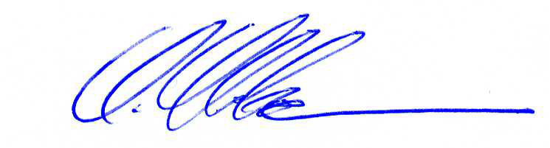
Dr. Amalia Gastaldelli Dr. Michael Roden Dr. Fritz Schick Dr. Hannele Yki-Järvinnen
EASD Study Group EASD Study Group EASD Study Group EASD Study Group
NAFLD Diab-Imaging Diab-Imaging NAFLD

Institute of Clinical Physiology Univ. Düsseldorf Univ. Tübingen Univ. Helsinki
National Research Council German Diabetes Center Tübingen, Germany Helsinki, Finland
Pisa, Italy Düsseldorf, Germany

